SISTER NIVEDITA MONTESSORY SCHOOL
CLASS- I
G.K
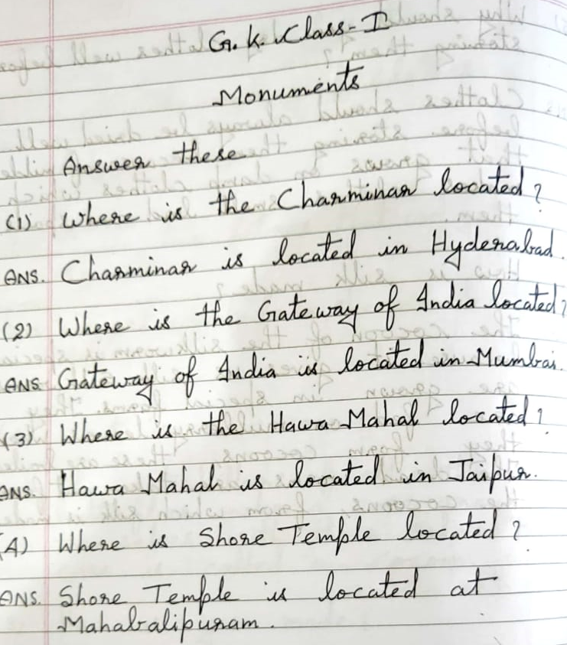

हिन्दी
याद करे और लिखे –
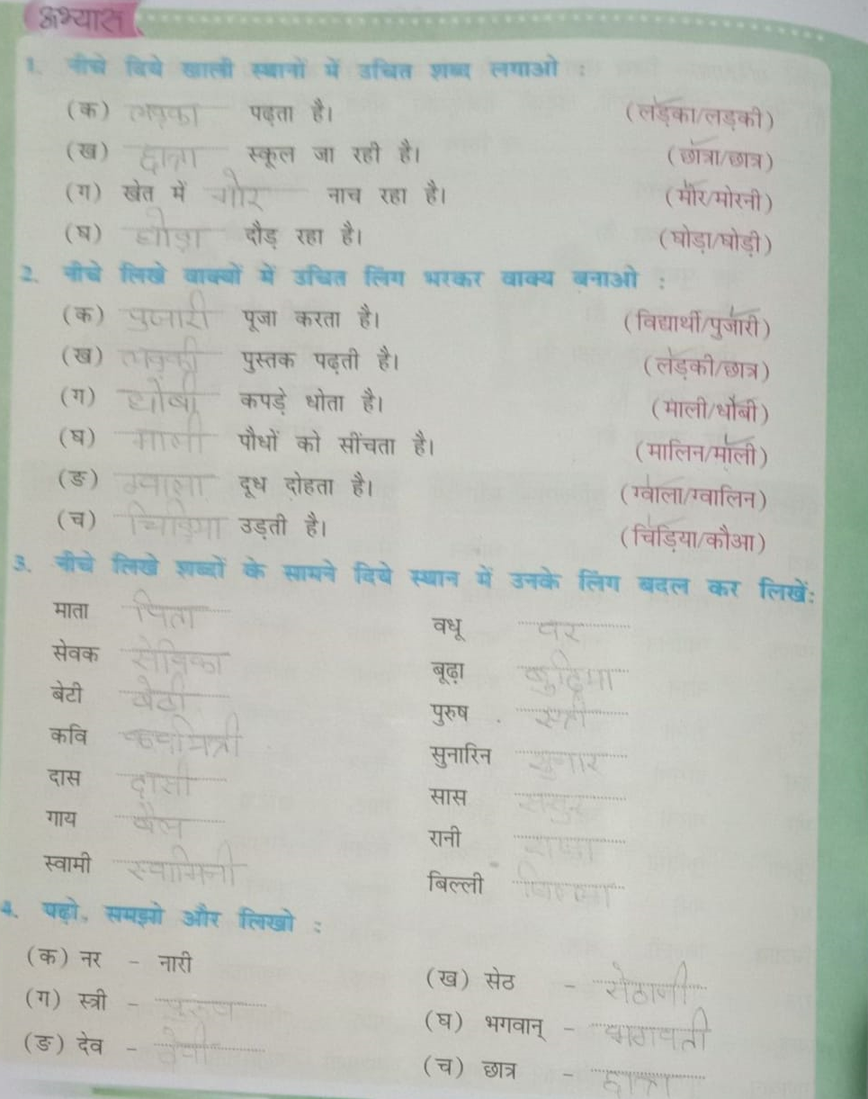

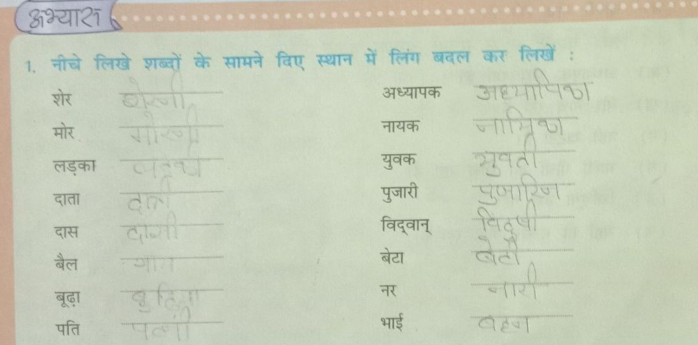

MATHS
COMPLETE PAGE NO- 12,13,15,16 & 17 SOLVE IT IN NOTEBOOK.
SCIENCE
