SISTER NIVEDITA MONTESSORY SCHOOL
NURSERY
HINDI
PRACTICE 3 PAGES
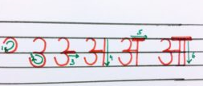
WRITING PATTERN EX BOOK 1- COMPLETE PG 15 & 16.
WRITING PATTERN EX BOOK 2 - COMPLETE PG 5.
PRACTICE NUMBER 1(ONE) - GO- OVER.

PRACTICE NUMBER 2 (TWO)- GO –OVER PRACTICE NUMBER 3 (THREE)- GO -OVER
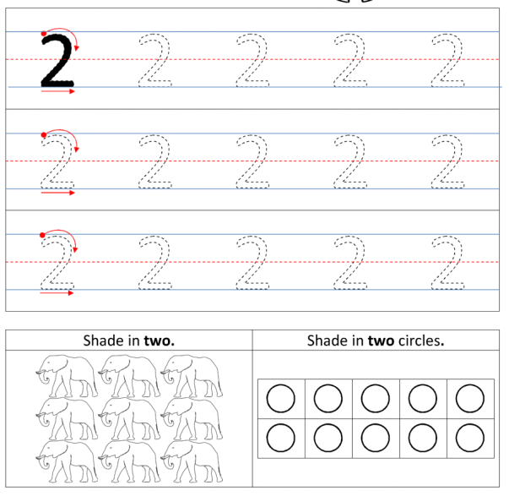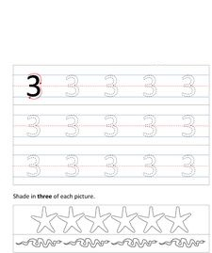
PUT YOUR FINGER & READ “A” TO “D” FROM PICTURE PRIMER.
PUT YOUR FINGER & READ   FROM AKSHAR PARICHAY
PUT YOUR FINGER & READ “1” TO “30” FROM FILE.
RHYMES- FROM FILE ONLY 1 ENGLISH.

