SISTER NIVEDITA MONTESSORY SCHOOL
NURSERY
PRACTICE 3 PAGES
HINDI

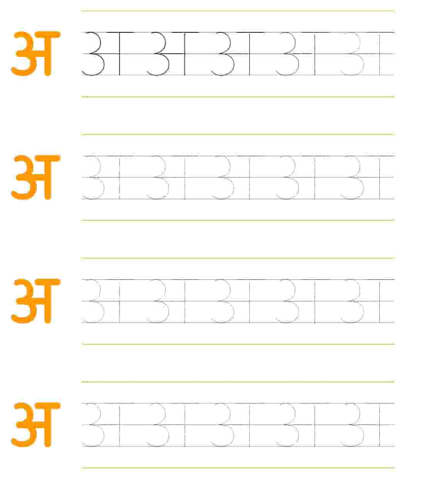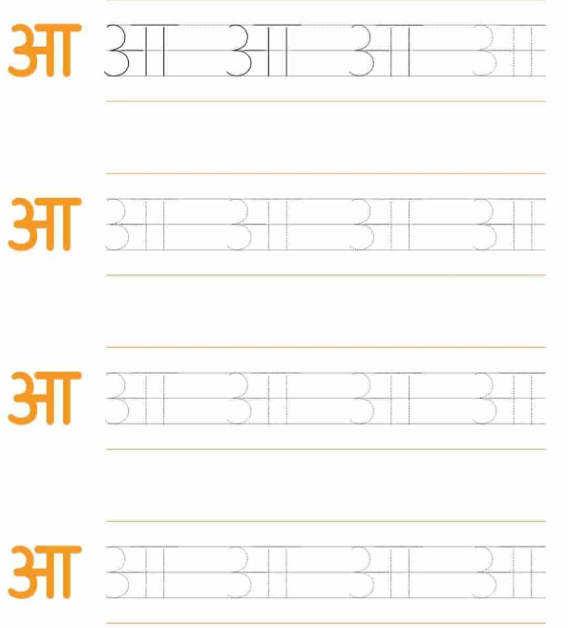

WRITING PATTERN EX BOOK 1- COMPLETE PG 17 & 18.
WRITING PATTERN EX BOOK 2 - COMPLETE PG 6.

DRAWING
COLOUR IT.
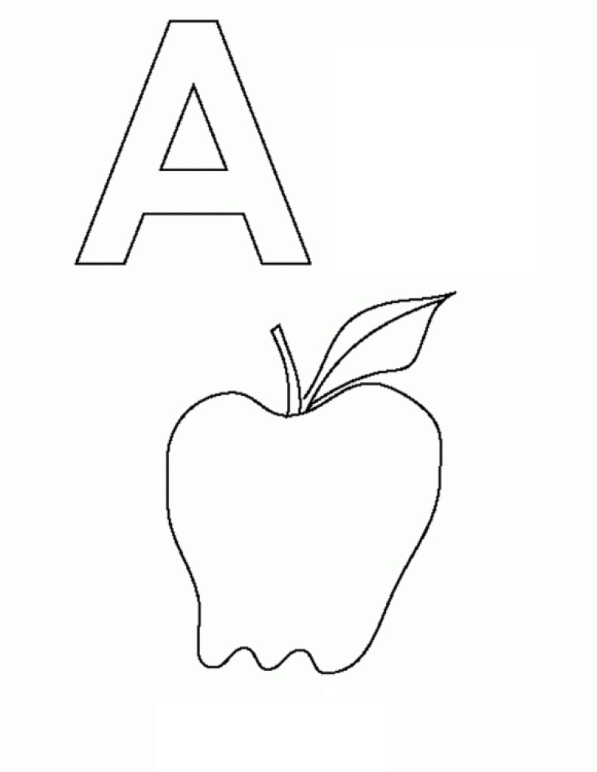

MATHS
PRACTICE NUMBER 2 (TWO)- GO –OVER PRACTICE NUMBER 3 (THREE)- GO -OVER
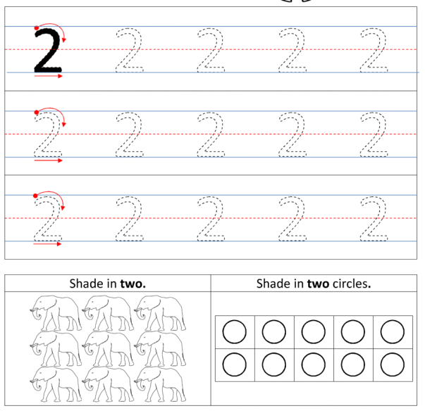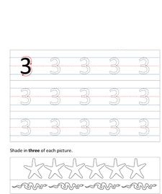
PRACTICE NUMBER 4 (FOUR)- GO OVER.
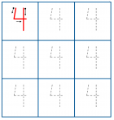

PUT YOUR FINGER AND READ FROM FILE.

“A” TO “Z”.

“1” TO “30”
LEARN IT
WHAT IS YOUR NAME?
WHAT IS YOUR FATHER’S NAME?
WHAT IS YOUR MOTHER’S NAME?
1 HINDI & 1 ENGLISH RHYMES FROM FILE.

