SISTER NIVEDITA MONTESSORY SCHOOL
CLASS- III
MATHS- SOLVE & PRACTICE.
PAGE NO- 3,&4 (EX- 1C &1D) FROM JUNIOR MATHEMATICS BOOK.
PAGE NO- 1 &2 FROM MENTAL MATHEMATICS BOOK.

SCIENCE-
CHAPTER-1 LIVING & NON- LIVING
COMPLETE IN COPY
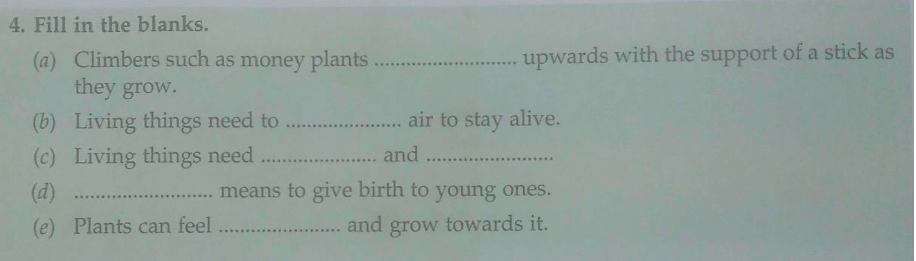
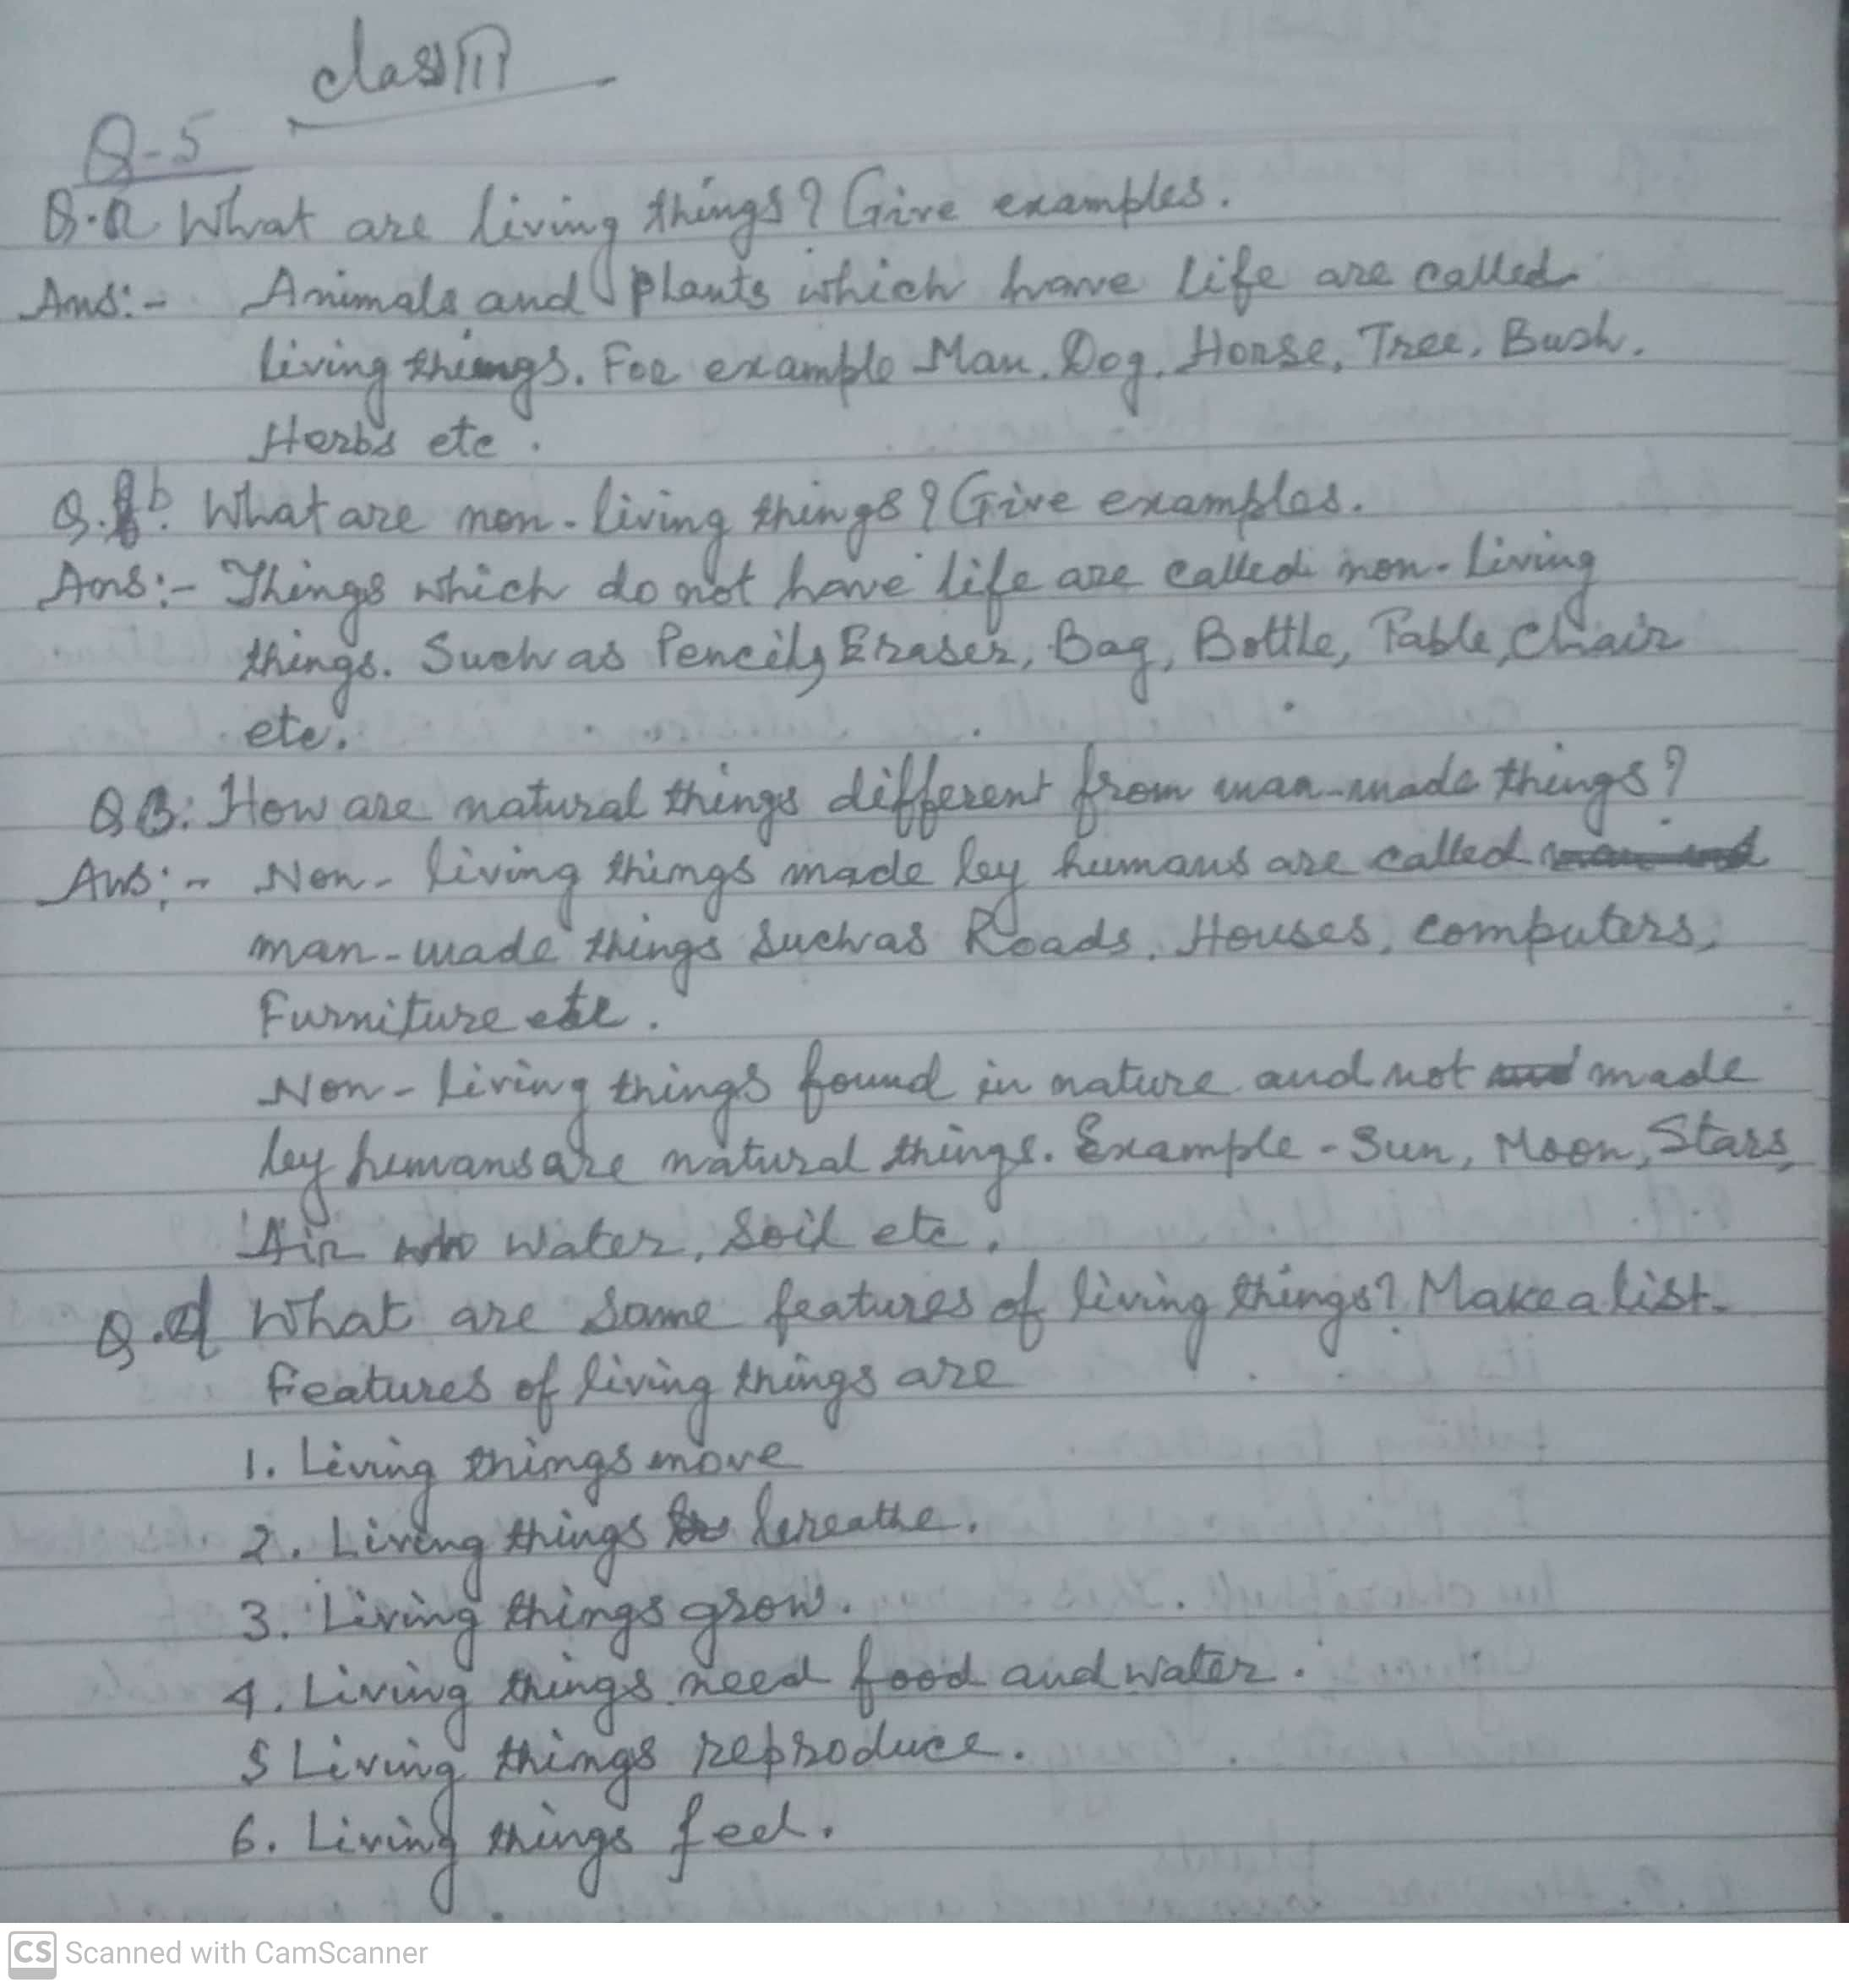
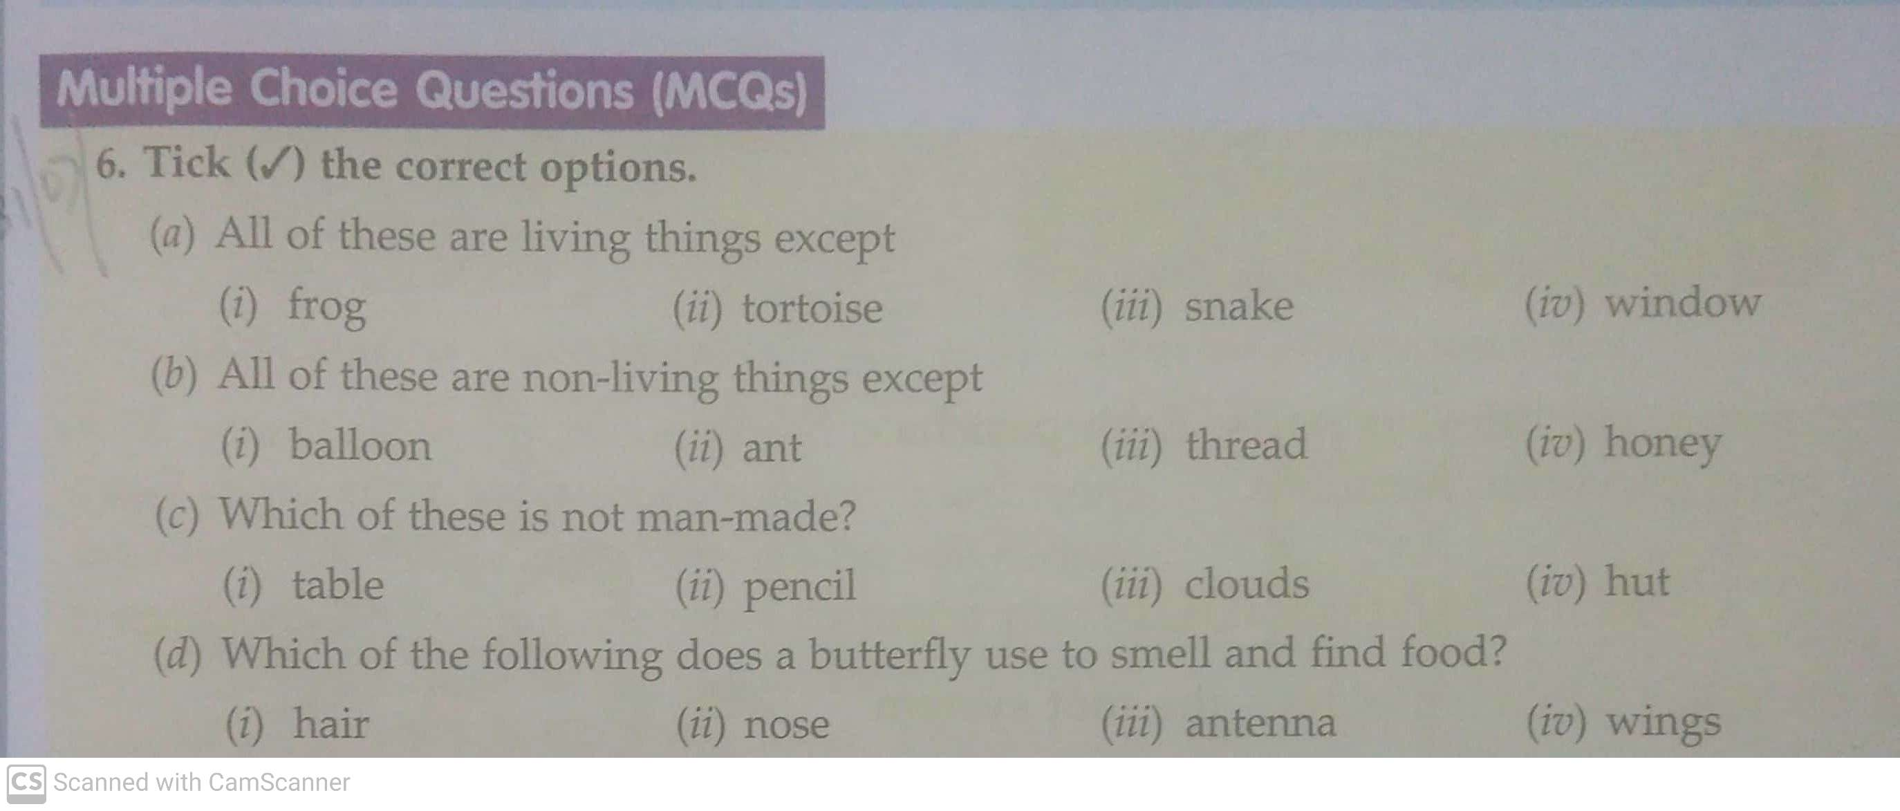

HINDI-
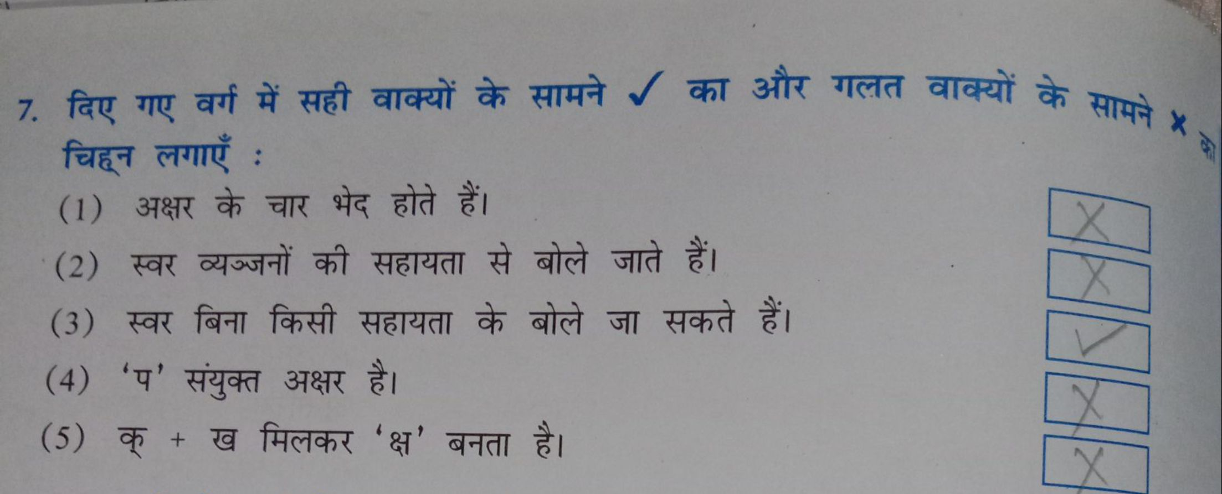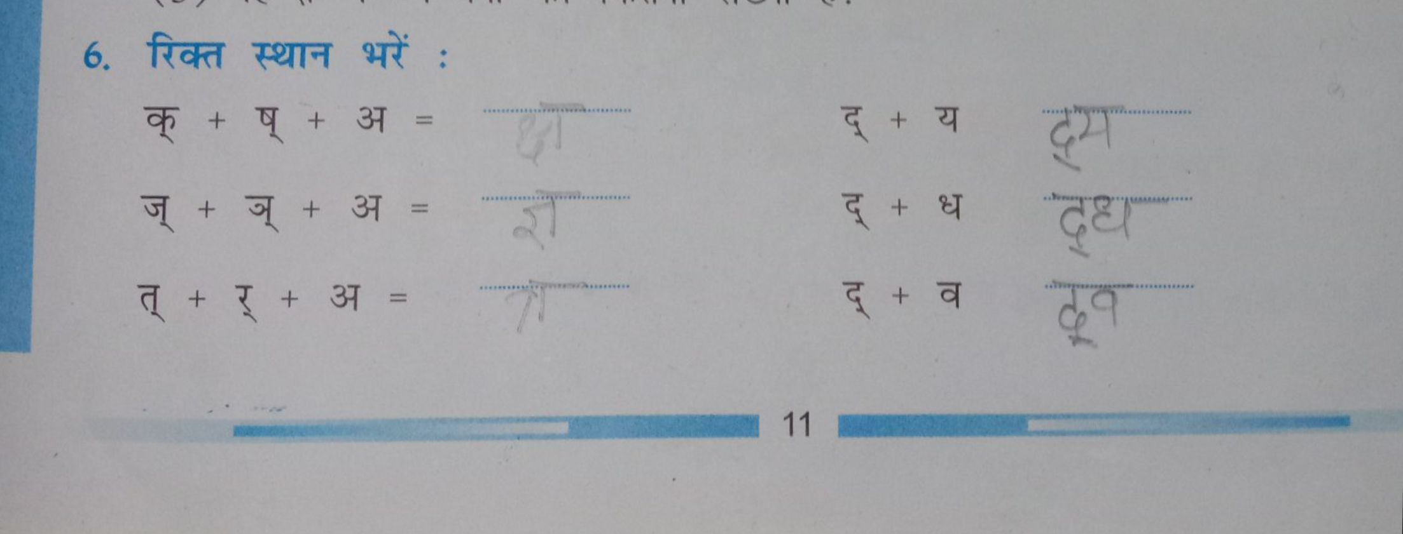

G.K-
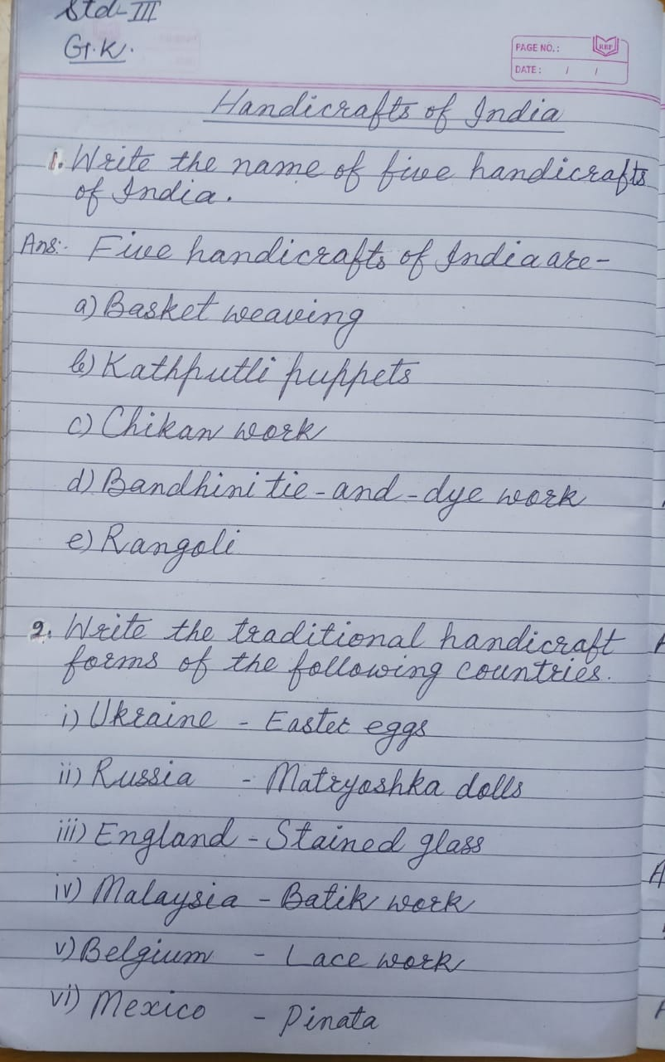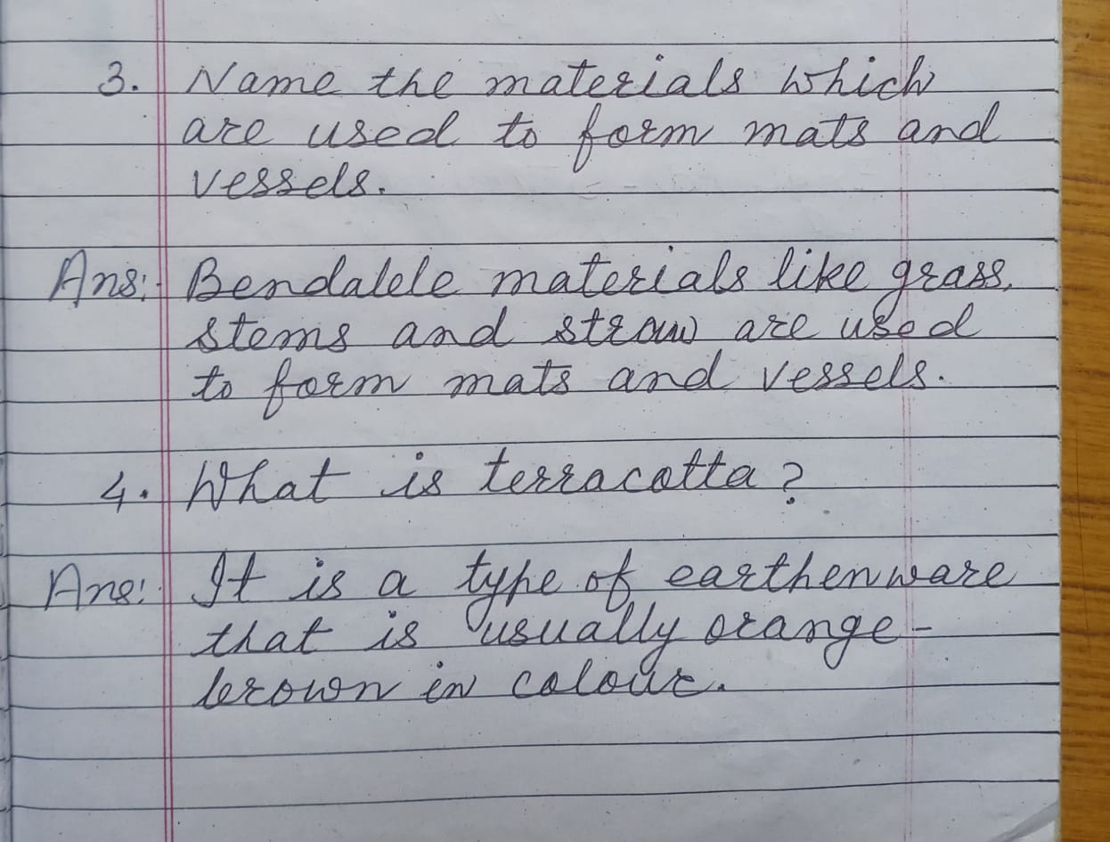

S.S.T-
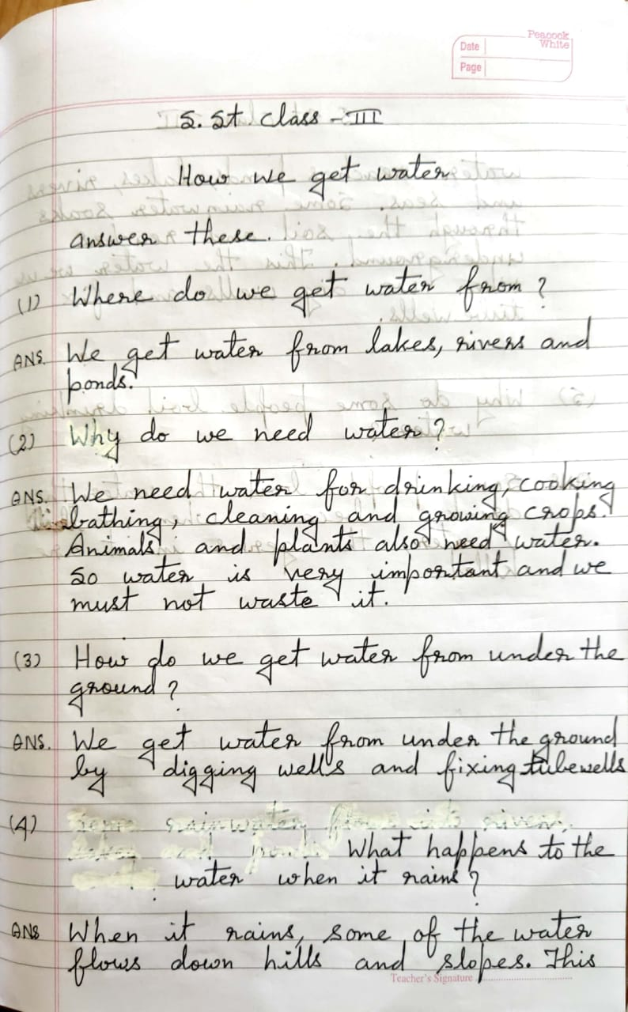
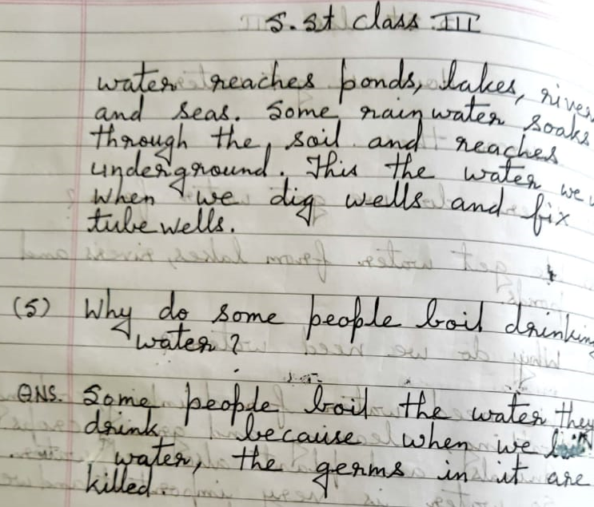

ENGLISH-
