SISTER NIVEDITA MONTESSORY SCHOOL
CLASS- IV
MATHS- SOLVE & PRACTICE.
PAGE NO- 2 & 3 (6-13) FROM JUNIOR MATHEMATICS BOOK.
PAGE NO- 1 &2(EX-1 & 2) FROM MENTAL MATHEMATICS BOOK.

SCIENCE-
CHAPTER-1 GREEN PLANTS
COMPLETE IN COPY
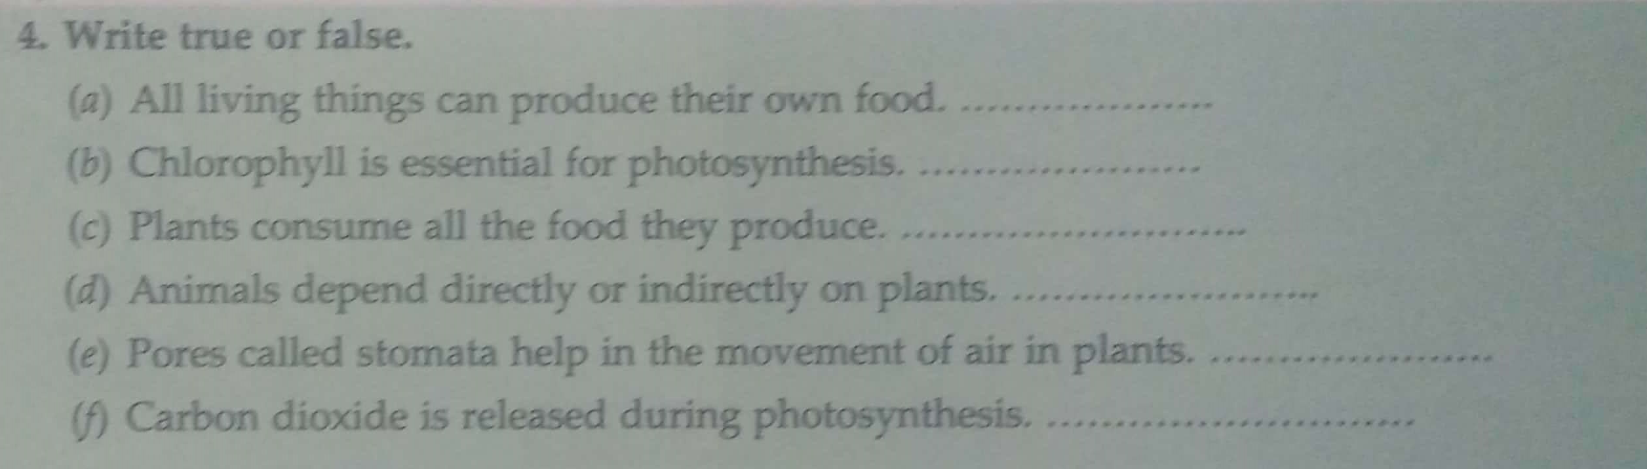
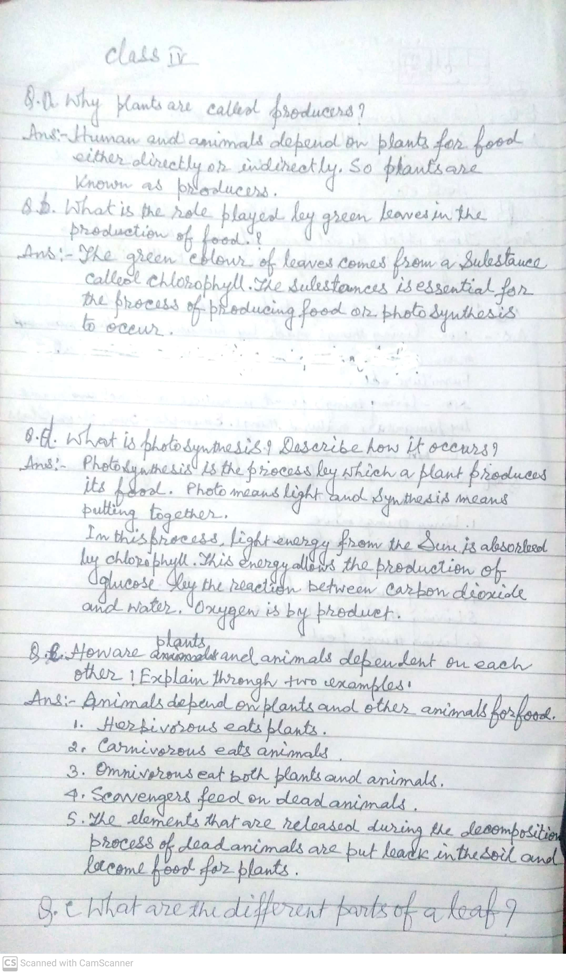

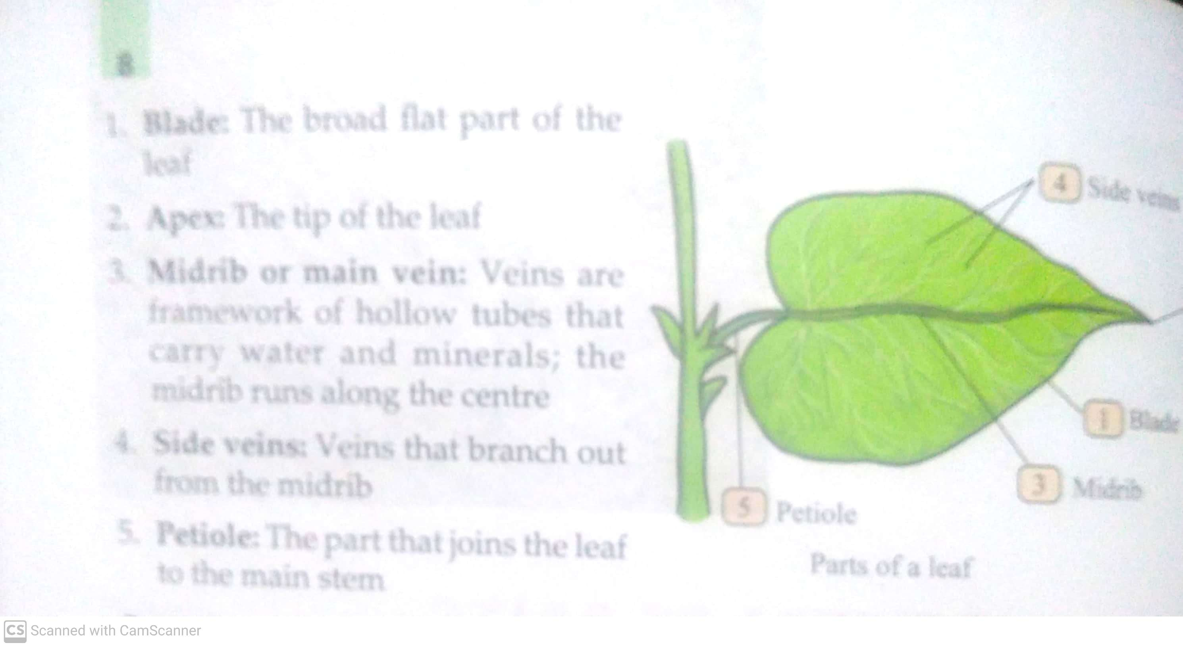
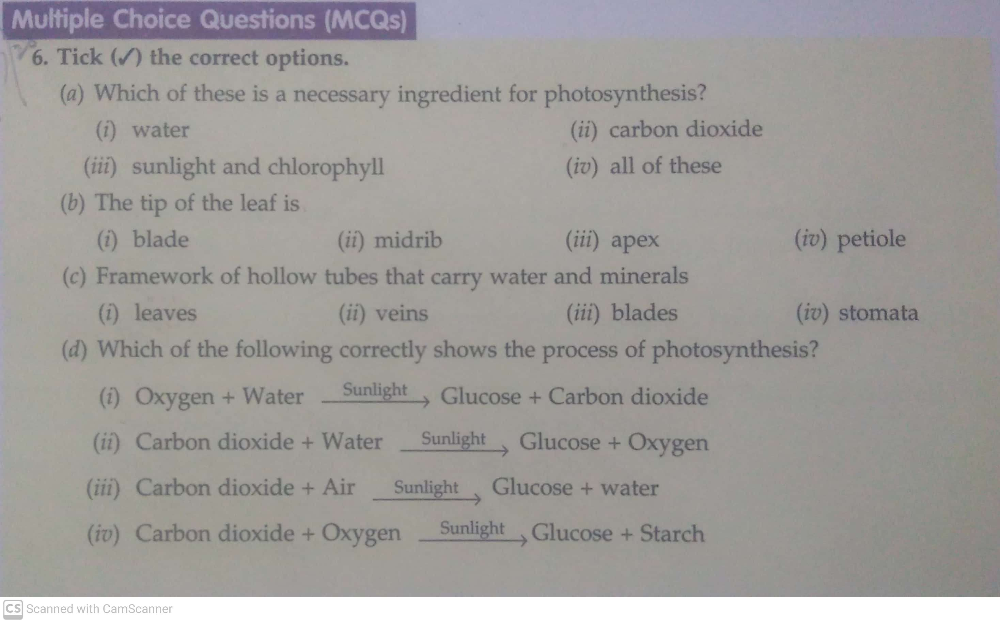

HINDI-
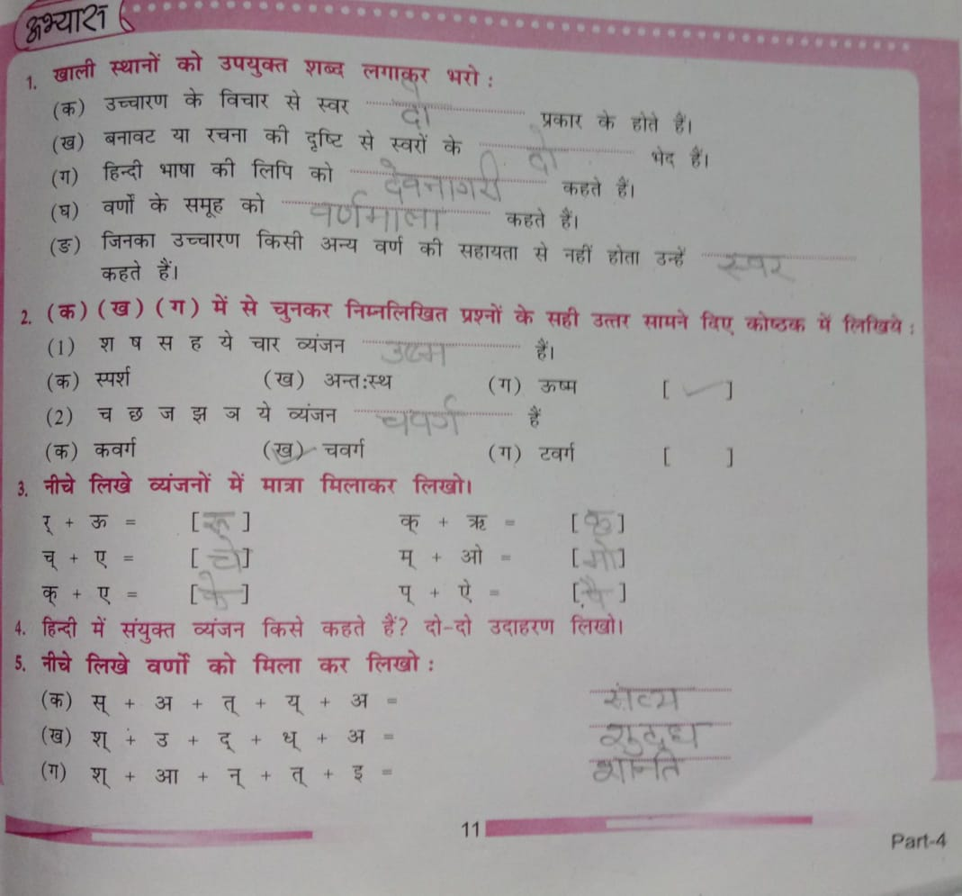
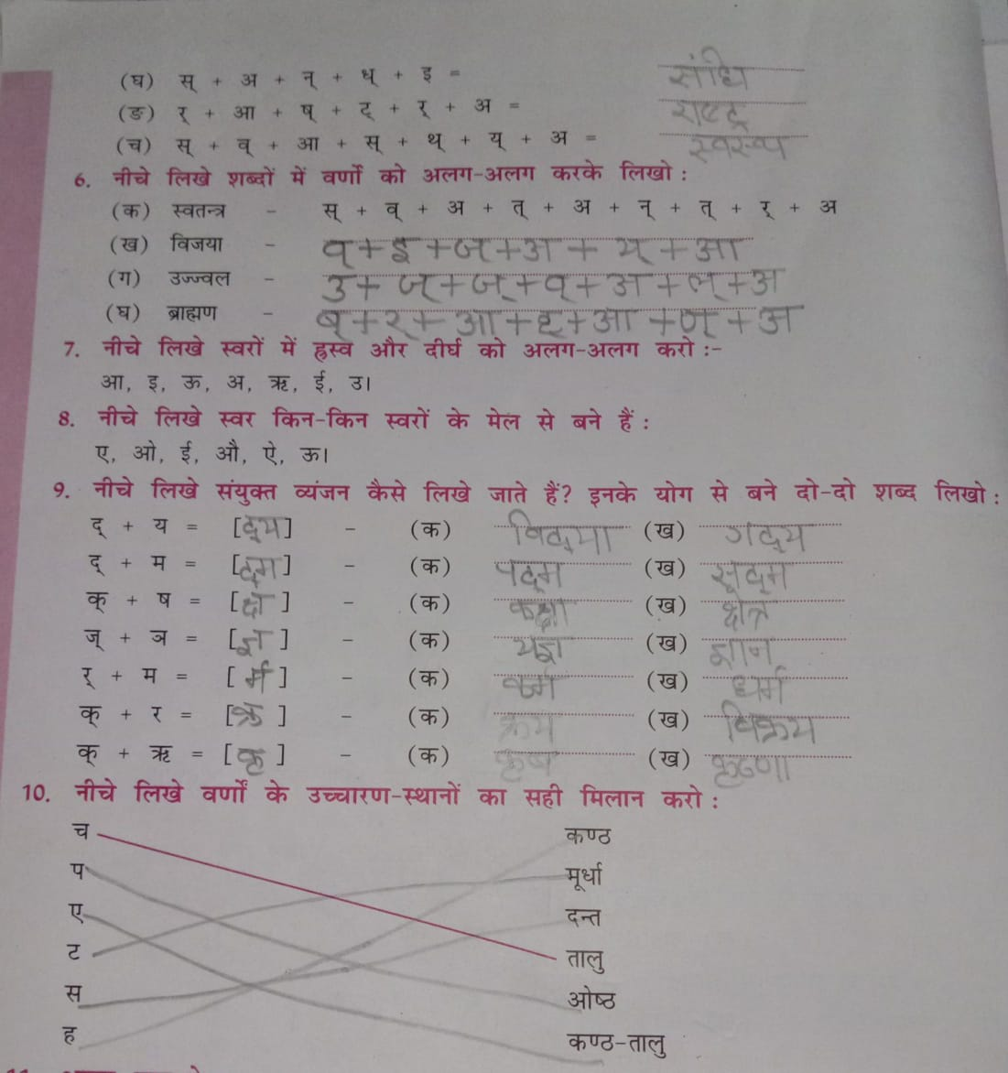

ENGLISH-
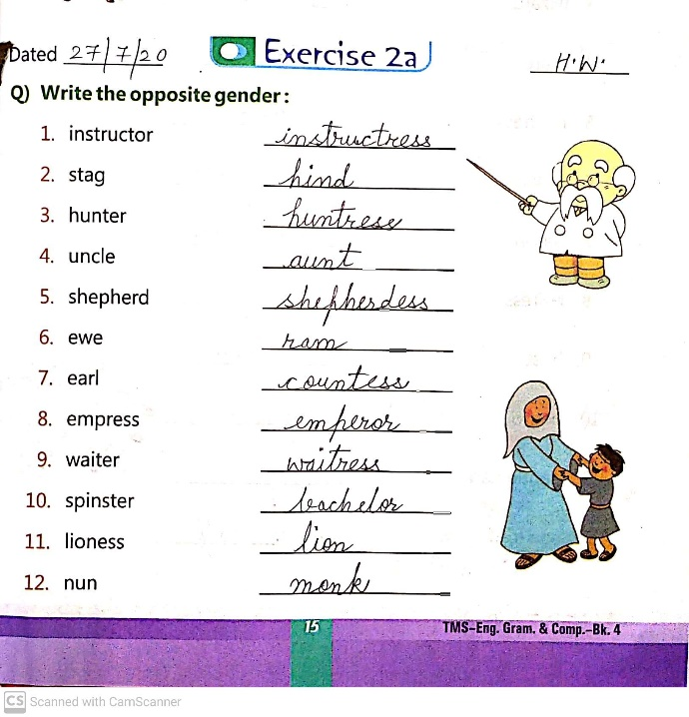
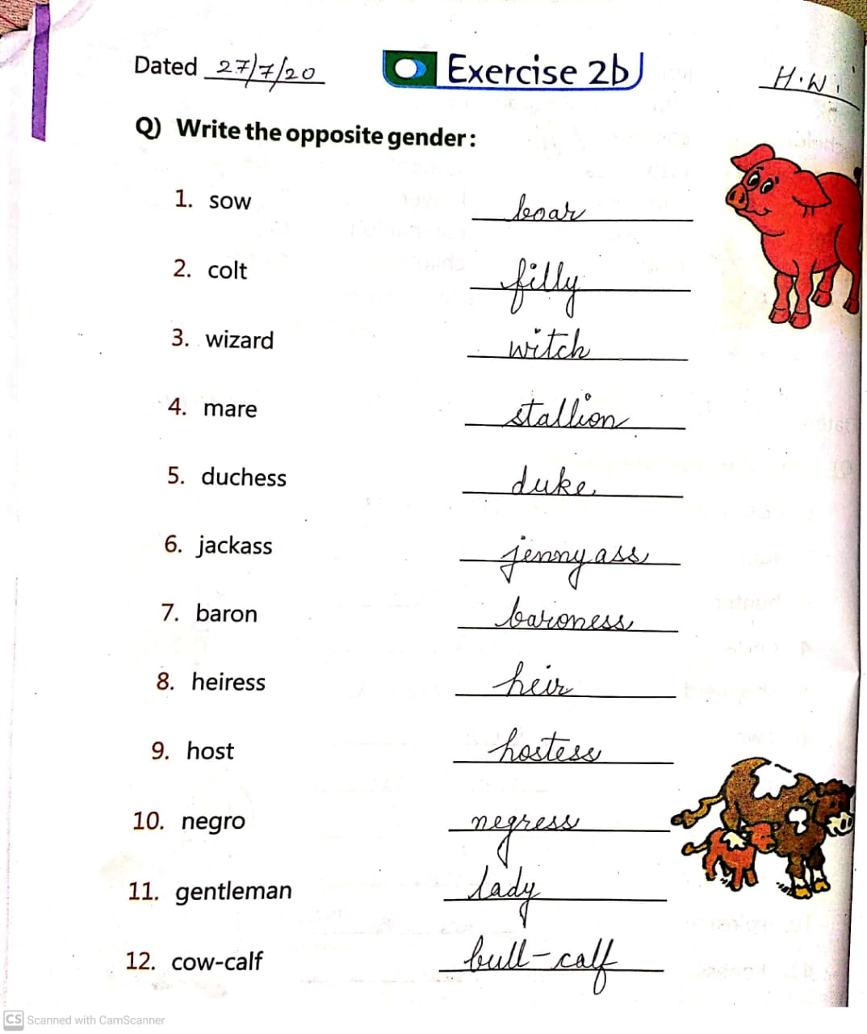
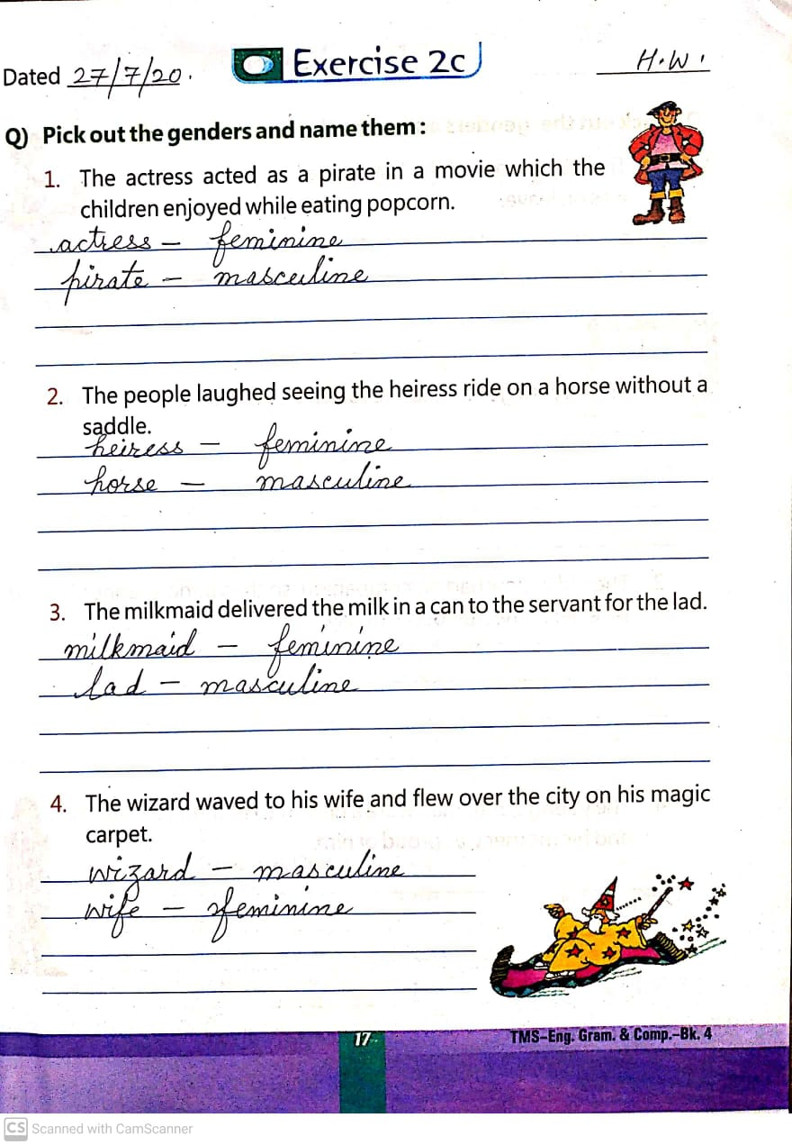
G.K-
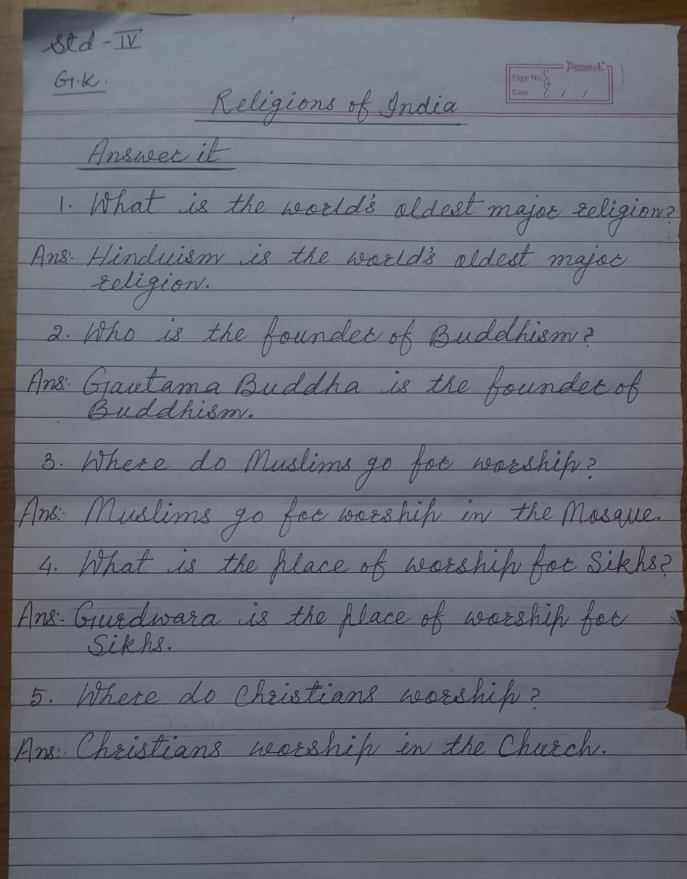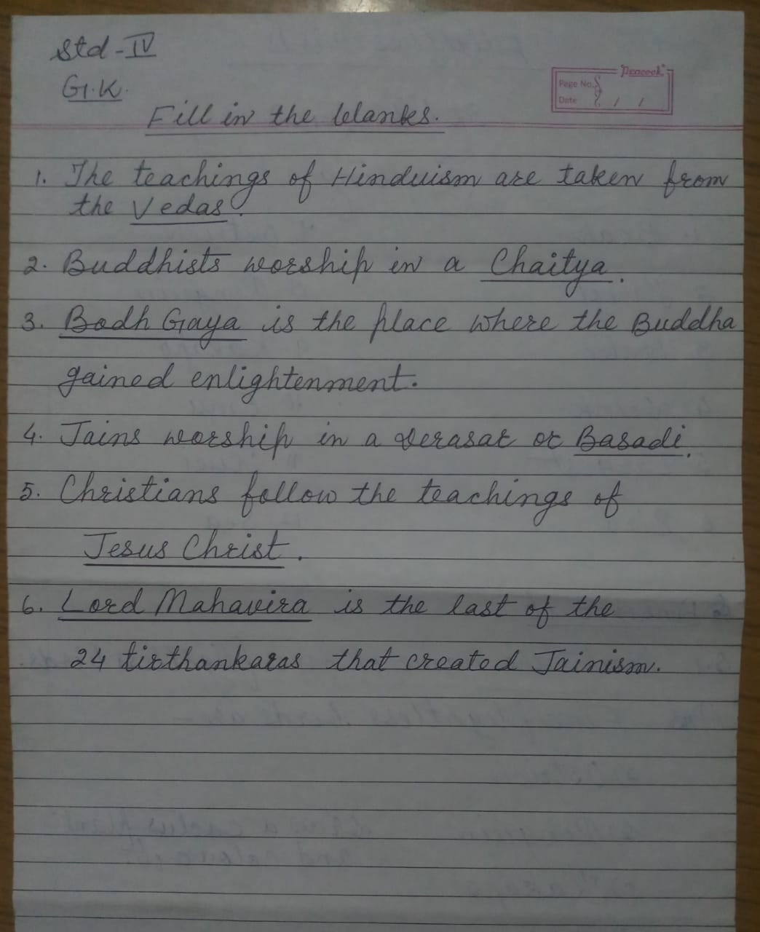

S.S.T-
