SISTER NIVEDITA MONTESSORY SCHOOL
CLASS- I
ENGLISH (MCB)
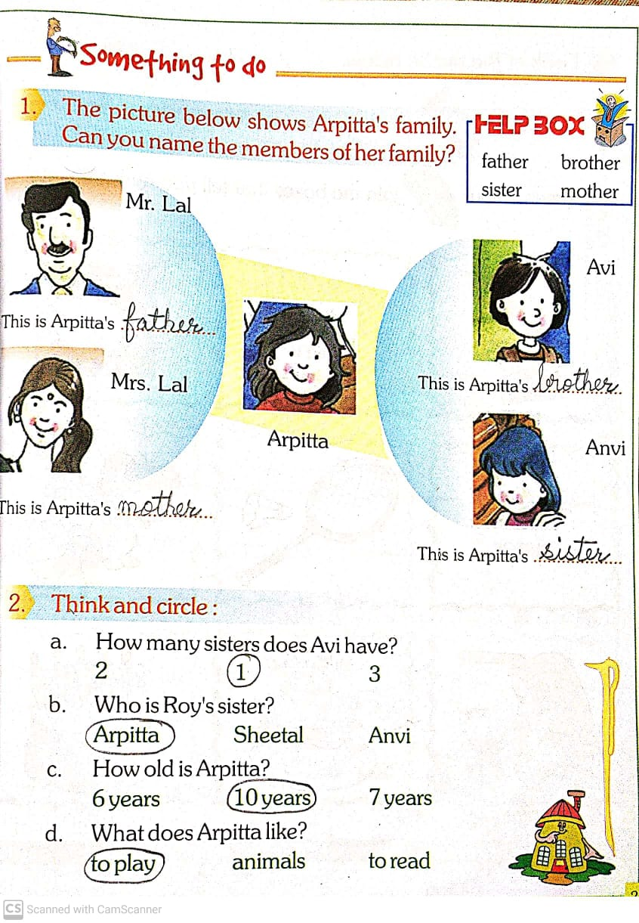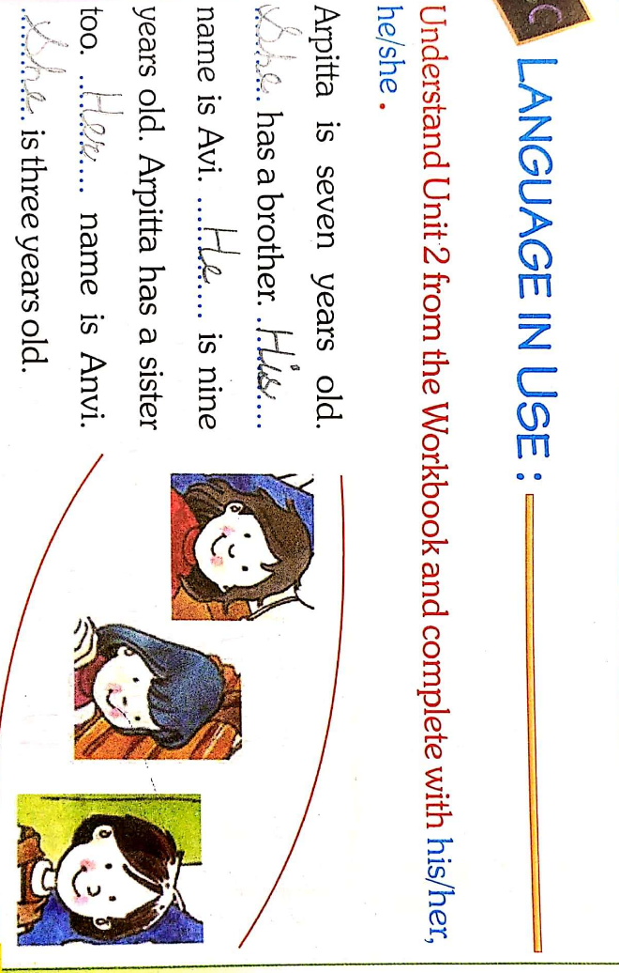

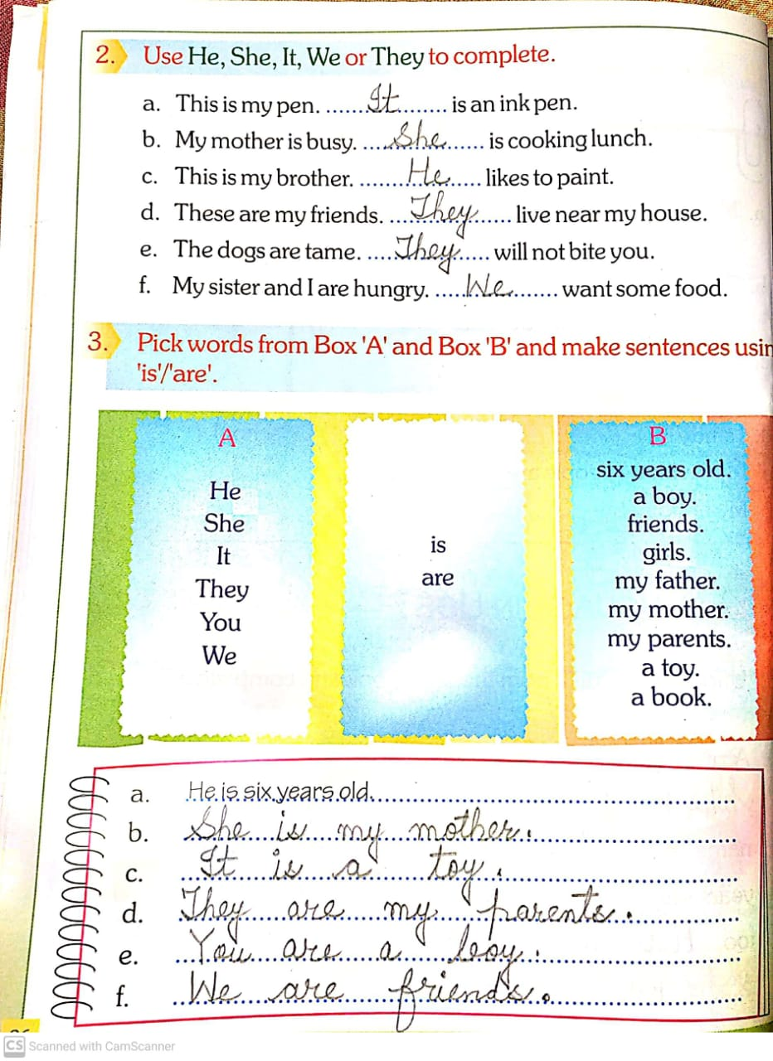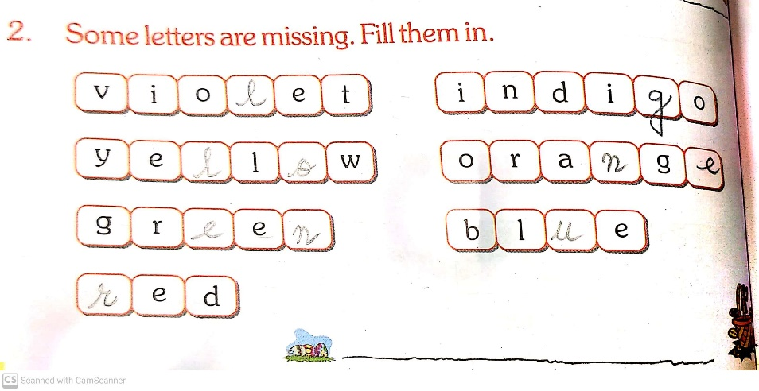
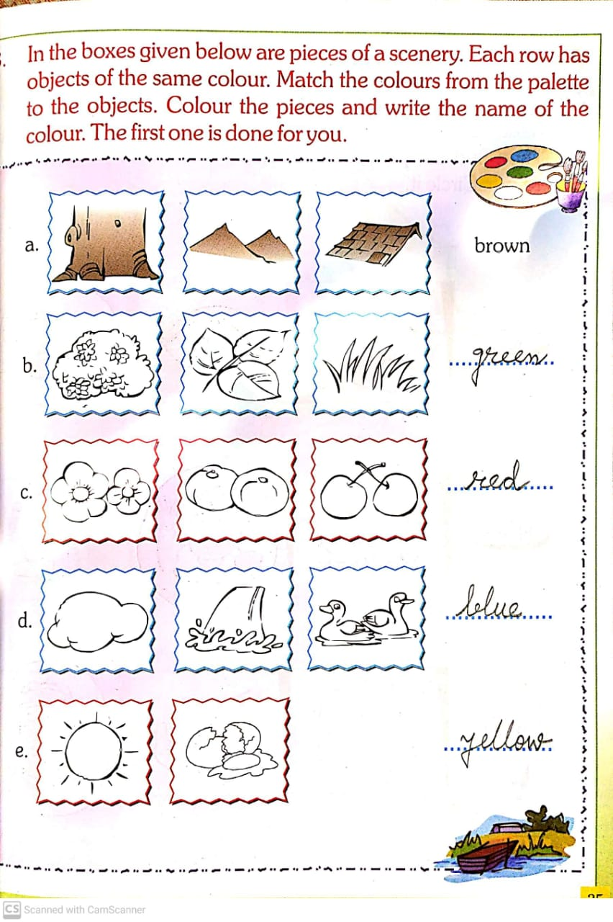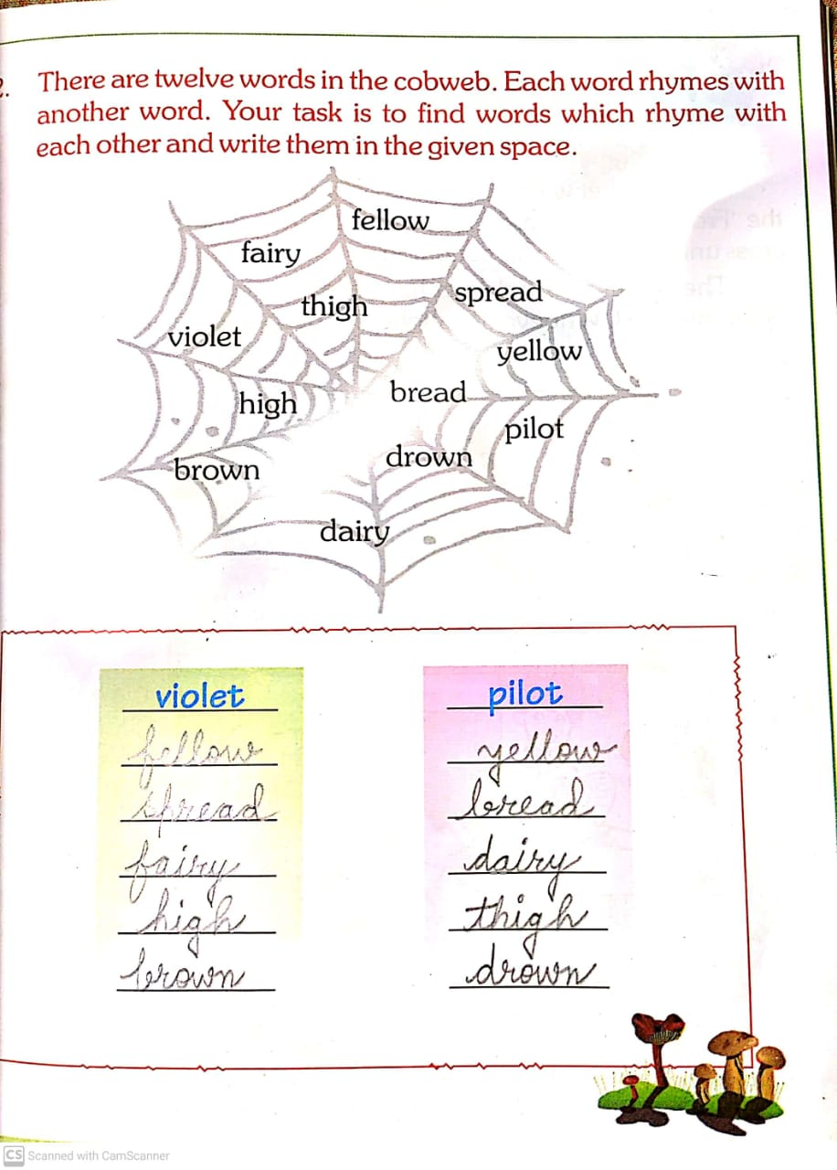
CHAPTER 2 &3. DO PAGE NO.- 24,27,28,29,32,33,&36.

SCIENCE
LEARN & WRITE BOOK & NOTEBOOK.
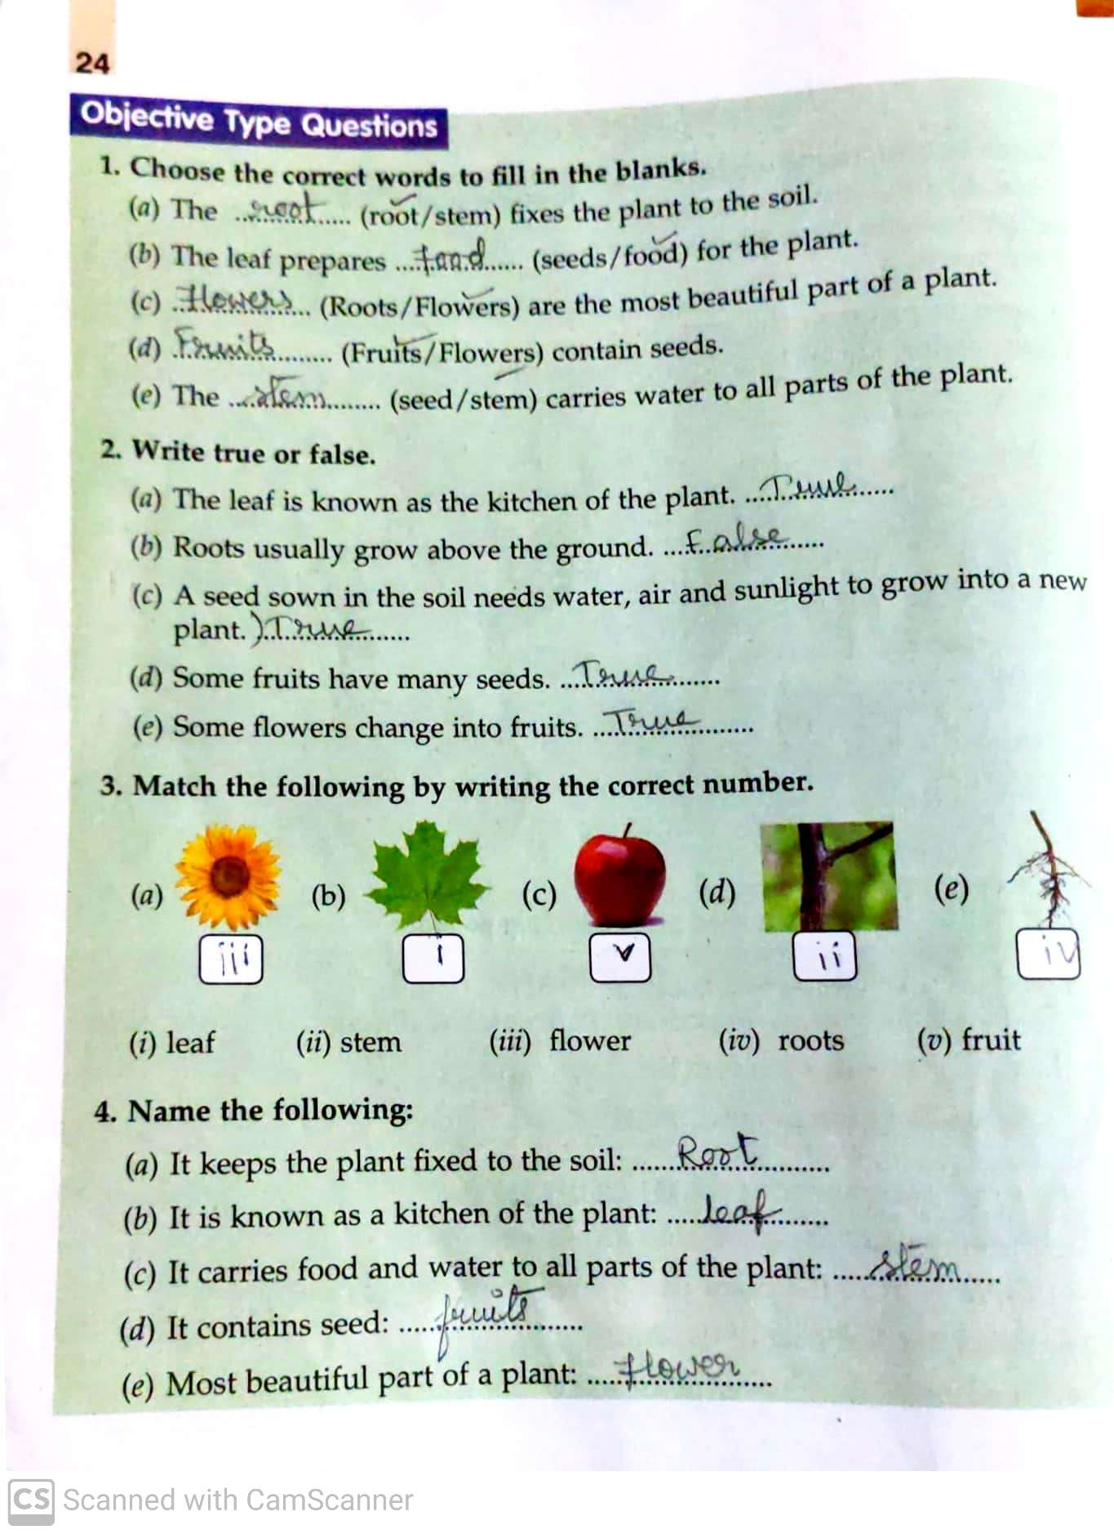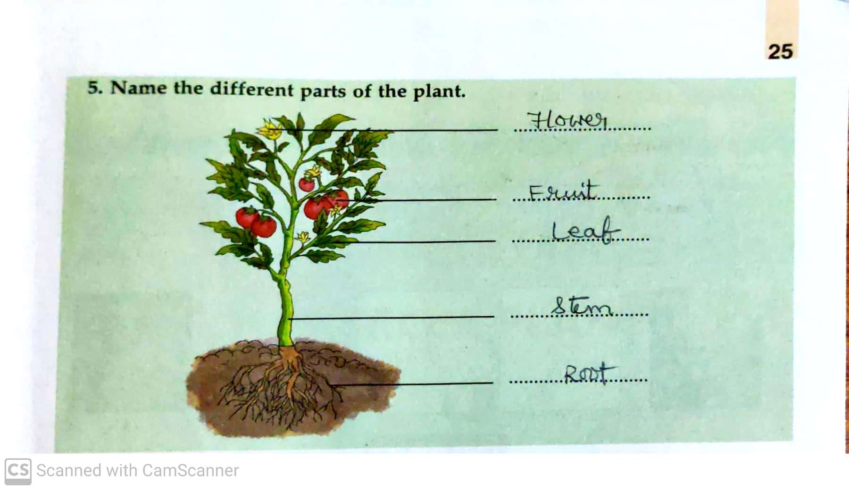
JUNIOR MATHS.
SOLVE & PRACTICE PG.NO- 8,9,10&11.

