SISTER NIVEDITA MONTESSORY SCHOOL
CLASS IV
10 DAYS WORK
MATHS
JUNIOR MATHS BOOK- COMPLETE PAGE NO 4 & 5 Q. NO – 4 TO 12 IN EXERCISE BOOK
MENTAL MATHS PAGE NO- 3,4 &5 EX- 3,4 &5

SCIENCE
COMPLETE PAGE NO- 24 Q.NO- 4,5 & 6 IN EXERCISE BOOK.
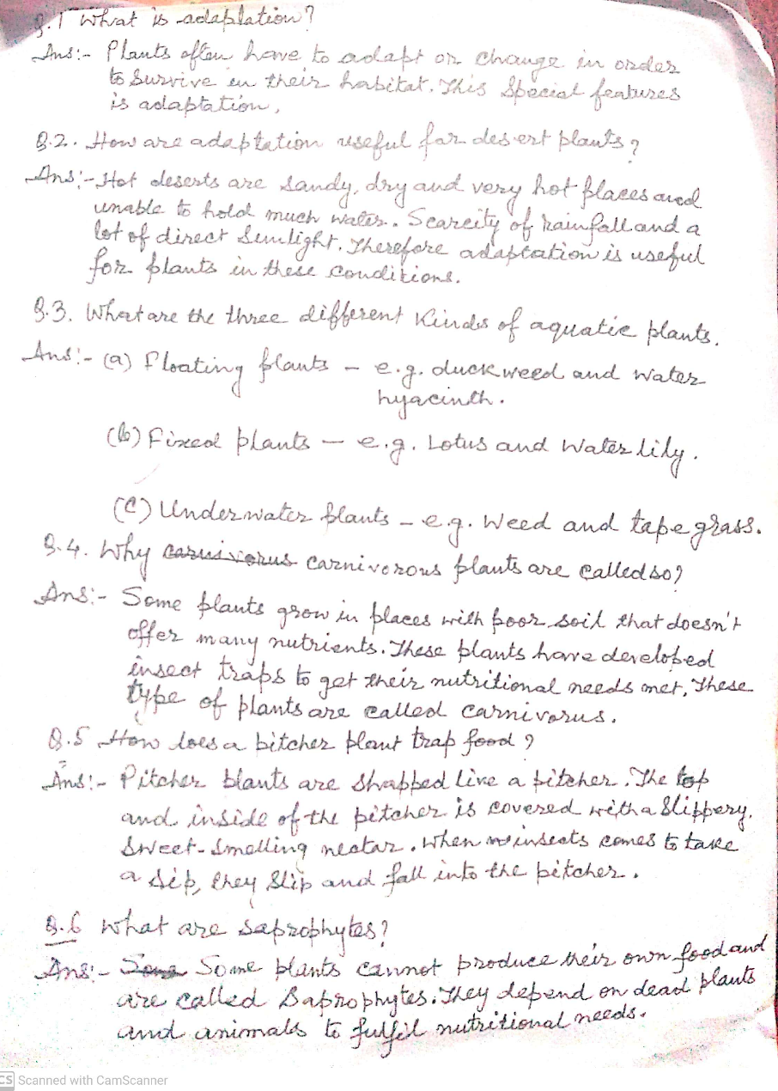
S.S.T
COMPLETE ALL THE OBJECTIVE TYPE QUESTIUONS TILL CHAPTER “THE MAKING OF CLOTHES”

