SISTER NIVEDITA MONTESSORY SCHOOL
CLASS- III.
SCIENCE.
LEARN & WRITE.
COMPLETE PAGE NO- 20
Q 5 &6
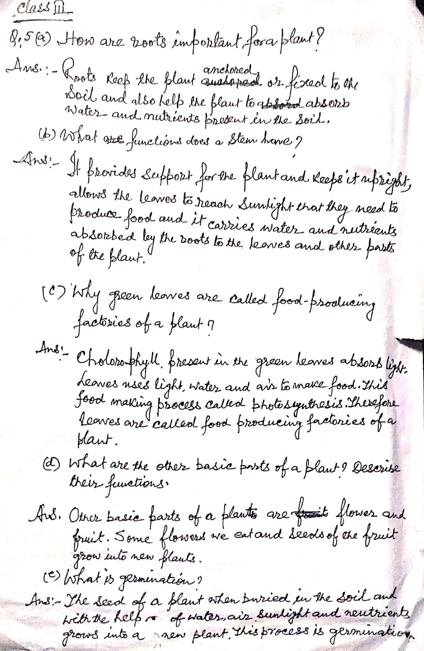

MATHS
COMPLETE PAGE NO- 11 TO 18 ( ATLEAST 3 PROBLEMS OF EVERY QUESTIONS.) JUNIOR MATHS BOOK.
MENTAL MATHS- EX-5 PG.NO-5
S.S.T
COMPLETE ALL THE OBJECTIVE TYPE QUESTIONS TILL CHAPTER HOW WE GET WATER.

